Advanced Lung Segmentation Project
Lung Segmentation with Optimized Attention U-Net and DAR-UNet



BY: Saja Hamasha 164806
Sara Jaradat 165199
Fairouz matalkah 164401
Sabaa Al-Azzam 165890

Course instructor: Dr. Abdullah Al-Amaren

- Problem Statement
The trustworthy identification of lung regions from chest X-ray (CXR) images plays a very important role in disease detection, volume measurement and radiation treatment planning and so on which are all downstream works depending on this identification
Manual lungs segmentation consumes a lot of time and is often different from one observer to another hence the necessity of using automated deep learning methods
This project is focused on binary lung segmentation deep learning models development, training and evaluation as well as accuracy and efficiency effectiveness analysis
The two discussed architectures are: an Optimized Attention U-Net baseline and a novel Dual Attention Residual U-Net (DAR) with attention and residual blocks.
The models are trained using combined lung datasets and a separate test set is used for evaluation
Further analyses involve the following: scalability with dataset size, boundary precision, uncertainty estimation and advanced diagnostic reports

- Research on Neural Networks and Architectures
2.1 Classical U-Net and Variants
U-Net is an architecture of a convolutional neural network that is widely used for segmentation of biomedical images
The main features of the U-Net structure are the capturing of the context by the contracting path (encoder) and the enabling of precise localization by the symmetric expanding path (decoder) at the same time
Skip connections between the corresponding layers of the encoder and the decoder are used to recover the fine-grained spatial information
U-Net was first suggested for the segmentation of neuronal structures in microscopy images (data.lhncbc.nlm.nih.gov ) and has since been the basis of many medical segmentation models
2.2 Attention U-Net
Attention U-Net came up with attention gates which got rid of unimportant areas in skip connections and brought out the important features
These gates adapt to different target structures in terms of shape and size
The optimized Attention U-Net which is used in this project combines attention gates with the use of dropout and batch normalization leading to better regularization and faster convergence as a result
2.3 DAR-UNet (Dual Attention Residual U-Net)
The new DAR-UNet is an advanced version of U-Net that integrates residual blocks functioning with dual attention mechanisms
Every encoder block has a residual convolutional path along with a shortcut path
A channel attention module is responsible for making the transport of informative feature channels more visible and a spatial attention module is responsible for marking the important locations
Residual connections help to diminish the effect of vanishing gradients
A decoder that is also attention gated similar to that of Attention U-Net, is used for the purpose of skip fusion
The resulting feature representation is better but the number of parameters remains close to that of the baseline model
- Dataset Description and Pre-processing
3.1 Datasets
Three public datasets were combined for training and evaluation:
Dataset | Source & description | images /  masks
Montgomery County CXR | Created by the US National Library of Medicine and the Department of Health and Human Services; 138 chest X-rays (4020×4892 px) collected in atuberculosis screening programme  Images are provided in PNG format with pixel spacing 0.0875 mm and include 80 normal cases and 58 abnormal cases  Manual lung masks were delineated by radiologists following anatomical boundaries  excluding lung parts behind the heart | 138  images &  masks
Shenzhen CXR | Compiled in 2012 by Shenzhen No. 3 People’s Hospital and Guangdong Medical College as part of a tuberculosis control project.  It contains 662 images with binary lung masks (336 TB cases and 326 normal cases) masks were annotated by radiologists | 662  images &  masks
Darwin CXR | The Darwin COVID-19 CXR Images Dataset comprises 6500 chest X∼ -ray images with  pixel-level polygonal lung masks annotated by radiologists  Among them 517 cases show COVID-19 infection | 6500  images &  masks

3.2 Pre-processing and Data Augmentation
All images were resized to 256×256 pixels and normalised to the range [–1, 1] after conversion to three channel RGB
Masks were binarised and resized using nearest neighbour interpolation to preserve label integrity
Data augmentation was applied only during training and included random horizontal/vertical flips, small rotations (±10°) and random intensity scaling
These augmentations help the models generalise to variations in orientation and intensity
3.3 Train–Validation–Test Splits
The datasets were merged and shuffled before splitting into three subsets using configuration A (70 %train / 15 % validation / 15 % test ) , (B: (80 %train / 10 % validation / 10 % test)) and (C: (75 %train / 15 % validation / 10 % test ))
*were used in the scalability analysis , Splits were stratified to ensure similar proportions of images from each dataset across splits.
- Model Development and Training
4.1 Hyperparameter Configurations
Three hyperparameter configurations were tested for each architecture
The learning rates, batch sizes and dropout rates were chosen to explore different speeds and regularisation levels the table below summarises the settings:

Config name | Learning  rate | Batch  size | Dropout | Purpose
Config 1 (Fast) | 1 × 10 ³⁻ | 16 | 0.3 | Higher LR and larger batch accelerate training but  risk overshooting minima
Config 2  (Balanced) | 1 × 10 ⁴⁻ | 8 | 0.0 | Balanced trade-off between speed and stability
Config 3  (Cautious) | 5 × 10 ⁵⁻ | 4 | 0.5 | Small LR and high dropout emphasise regularisation  but slow convergence

4.2 Training Procedure
Models were implemented in PyTorch The binary segmentation problem was formulated using binary cross-entropy with logits as the loss function The Adam optimiser was used with the above learning rates Each configuration was trained for 10 epochs The best model checkpoint was selected based on validation Dice score Dice and IoU metrics were computed with threshold 0.5 on sigmoid outputs
4.3 Hyperparameter Effects
The balanced configuration (Config 2) consistently achieved the best validation performance for both architectures
Fast configuration converged quickly but sometimes showed slight overfitting the cautious configuration improved regularisation but achieved slightly lower Dice scores and significantly longer training times
- Models Testing and Evaluation
5.1 Performance on Validation Set
The table below reports the best validation Dice/IoU scores and training efficiency for each hyperparameter configuration and model (averaged over three runs):

Architecture | Config | Learning  rate | Batch | Batch | Params  (M) | Best Val  Dice | Best Val  IoU | Training  time (s)
Attention  U-Net | Config1 | 1e-3 | 16 | 0.3 | 7.85 | 0.9532 | 0.9106 | 679.6
Attention  U-Net | Config2 | 1e-4 | 8 | 0.0 | 7.85 | 0.9553 | 0.9145 | 688.8
Attention  U-Net | Config2 | 5e-5 | 4 | 0.5 | 7.85 | 0.9438 | 0.8943 | 763.9

Architecture | Config | Learning  rate | Batch | Batch | Params  (M) | Best Val  Dice | Best Val  IoU | Training  time (s)
DAR-UNet | Config1 | 1e-3 | 16 | 0.3 | 8.07 | 0.9533 | 0.9109 | 858.3
DAR-UNet | Config2 | 1e-4 | 8 | 0.0 | 8.07 | 0. 9163 | 0. 9163 | 906.6
DAR-UNet | Config2 | 5e-5 | 4 | 0.5 | 8.07 | 0. 9373 | 0. 8827 | 1042.0
The DAR-UNet achieved the highest validation Dice of 0.9562 and IoU of 0.9163 surpassing the baseline by a small margin but requiring more parameters and longer training time
Both models demonstrated stable convergence with balanced hyperparameters yielding the best trade-off betweenspeed and accuracy
5.2 Test Set Results
Model | Test Dice | Test IoU | Parameters | Inference speed (FPS)
Attention U-Net | 0.9531 | 0.9101 | 7.85 M | 219 FPS
DAR-UNet | 0.9559 | 0.9132 | 8.07 M | 76 FPS

DAR-UNet again attains slightly higher segmentation accuracy but at the cost of slower inference due to its dual attention and residual blocks
5.3 Scalability with Dataset Size
To study how performance scales with training data DAR-UNet was trained using splits A, C and B (70%, 75% and 80% training data, respectively)
The figure below shows the best Dice scores on training and validation sets for each split
The model generalises best at 75% training data and performance remains stable across splits. Increasing data beyond 75% offers diminishing gains and may introduce slight overfitting
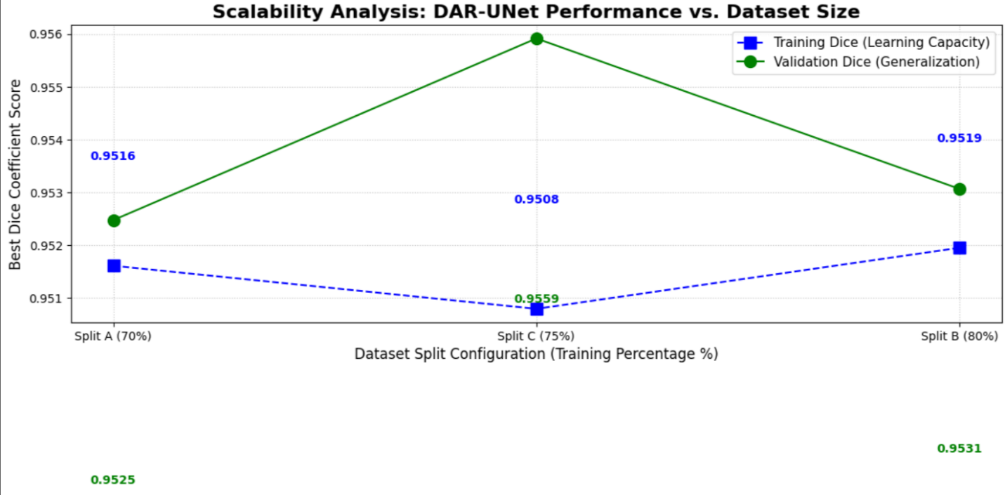

5.4 Boundary Precision
Boundary Dice evaluates overlap only along a thin band around the lung contour thus measuring the precision of boundary localization
DAR-UNet yields a boundary Dice of 0.7605 versus 0.7508 for Attention U-Net, indicating improved boundary accuracy
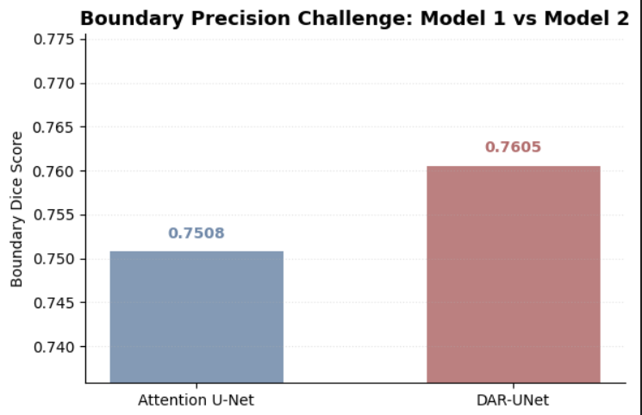
5.5 Comprehensive Benchmarking
The radar chart below summarises multiple aspects of performance: test accuracy, inference speed, model size, training efficiency and validation stability
Values are normalised for plotting and exact numbers are annotated
Attention U-Net excels in inference speed and training efficiency due to its smaller architecture while DAR-UNet achieves slightly better accuracy and validation stability
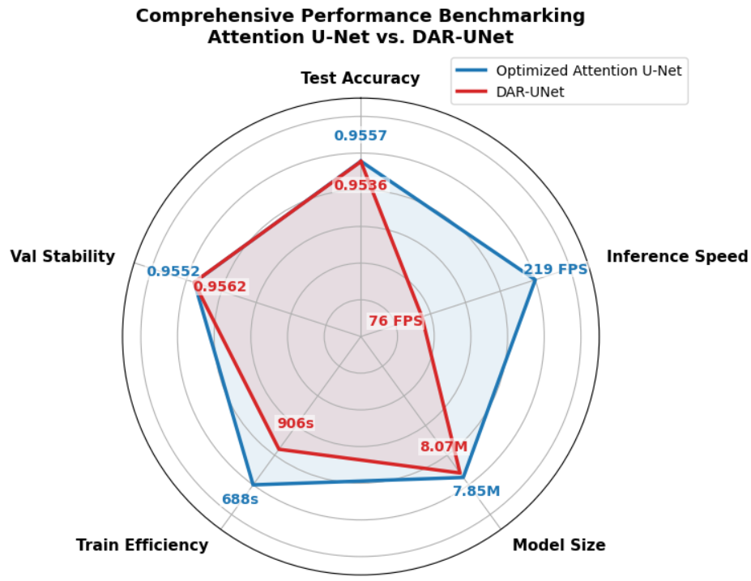
5.6 Qualitative Comparisons and Error Analysis
A random challenging case (#215) illustrates differences in predictions and error types between the two models
Both models segment the lung shape well however Attention U-Net shows minor under-segmentation near the apex whereas DAR-UNet introduces slight over segmentation along lateral edges
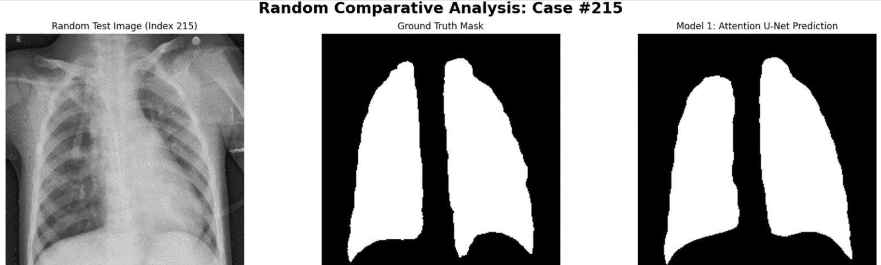
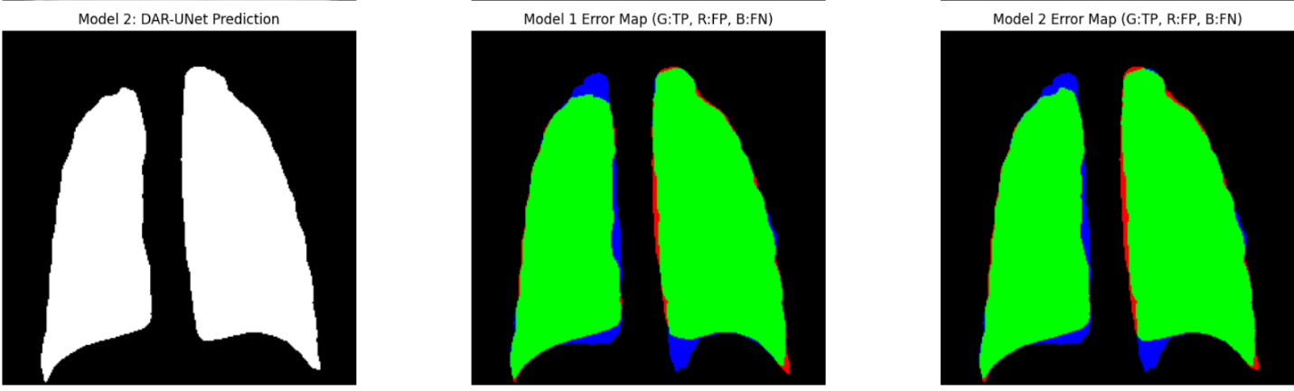

the boundary zoom figure highlights local misalignment along the ground-truth contour for a selected case
Attention U-Net shows slight inward deviation (blue) while DAR-UNet slightly over-shoots (red) in the same region
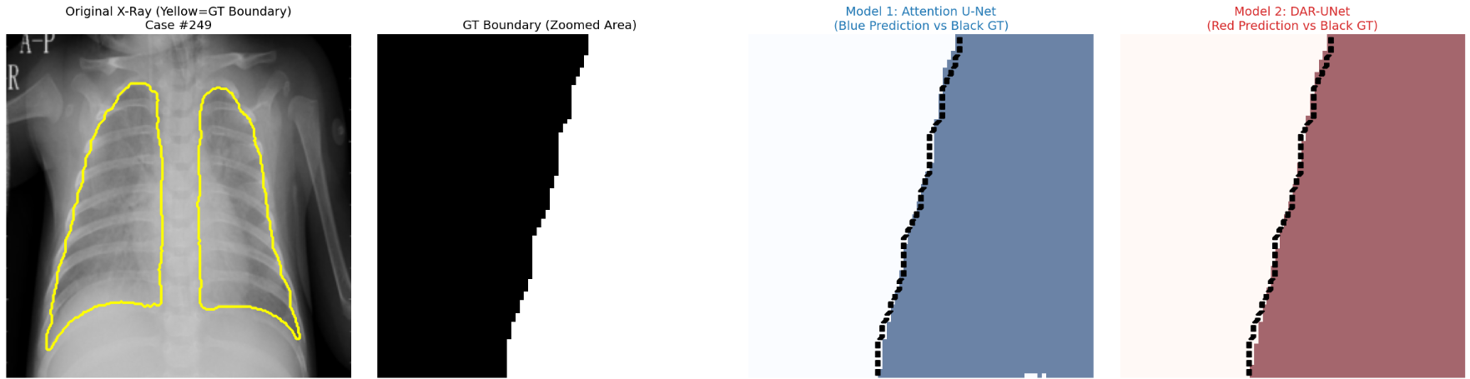

5.7 Spatial Uncertainty Analysis
Spatial uncertainty maps reveal where the model is uncertain about the segmentation
High uncertainty appears at lung borders and low contrast regions
The overlay helps identify areas requiring human review or additional training data two random examples are shown below
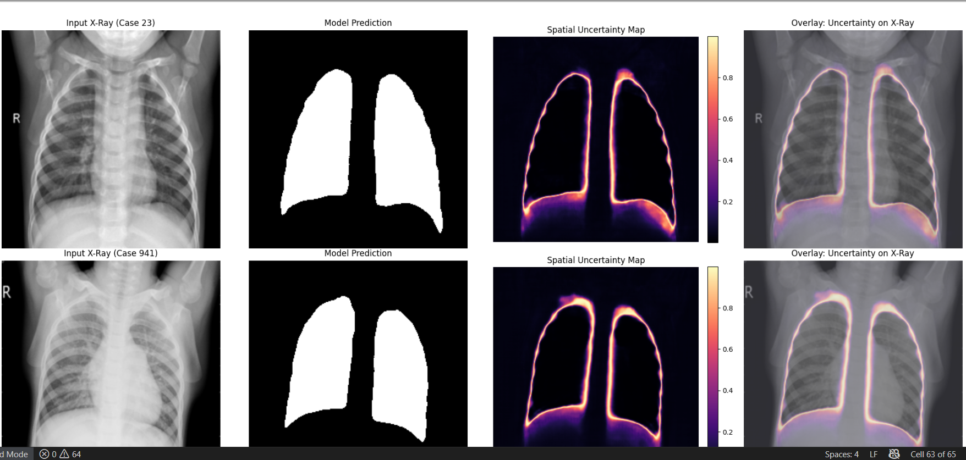

5.8 Advanced Diagnostic Report
An automated report combines segmentation overlays uncertainty maps and a diagnostic card summarising total lung area occupancy (percentage of image occupied by lungs) symmetry ratio between left and right lungs and confidence (based on uncertainty) Cases with low symmetry or high uncertainty are flagged for review
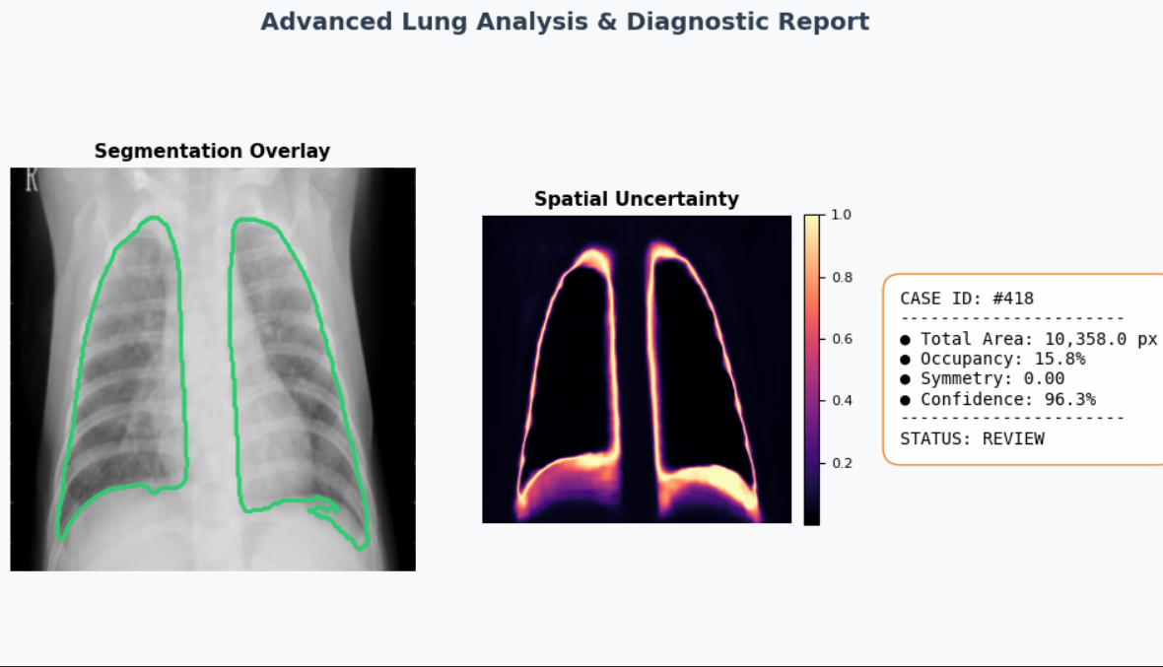

- Effectiveness Assessment and Computational Analysis
6.1 Memory and Computational Requirements
Both architectures have similar parameter counts (~8 M) with DAR-UNet being slightly larger
The attention and residual modules increase the number of operations resulting in slower inference (76 FPS compared to 219 FPS for the baseline)
Training times are longer for DAR-UNet due to greater depth and attention computations
6.2 Train–Validation Stability
Training curves demonstrate that both models converge quickly within five epochs
Validation Dice remains close to training Dice indicating good generalization
Balanced hyperparameters achieve the best stability
6.3 Scalability and Adaptability
DAR-UNet shows robust performance across different training sizes suggesting it can generalise well even with moderate data however the minimal improvement beyond 75% training data highlights diminishing returns
The model should be retrained or fine-tuned if new datasets introduce domain shifts(imaging modality or patient demographics)
7 Interface Development
The link (“https://lung-ai-awesfgthj.streamlit.app/”)
8 Critical Evaluation and Future Work
8.1 Strengths
• Comprehensive evaluation: The project integrates quantitative metrics (Dice, IoU, boundary Dice), scalability analysis, uncertainty estimation and diagnostic reporting
• Improved boundary accuracy: DAR-UNet’s dual attention and residual blocks enhance
boundary precision
• Explainability: Uncertainty maps and diagnostic cards provide transparency and help clinicians assess prediction confidence
8.2 Limitations
• Computational cost: DAR-UNet requires more training time and has slower inference, limiting
real-time deployment on limited hardware
• Symmetry estimation: Symmetry and confidence metrics need further refinement to account for complex lung shapes and pathological changes.
• Dataset bias: Training on CXR data from three datasets may still lack diversity models may not generalise to different modalities (CT scans) or pathologies (pneumothorax)
8.3 Future Improvements
• Multi-class segmentation: Extending the models to segment additional structures (heart, clavicles) would enable comprehensive thoracic analysis
• Semi-supervised or self-supervised learning: Leveraging unlabelled CXR data could improve generalisation and reduce annotation costs
• Model compression: Techniques such as pruning, quantisation or knowledge distillation could
reduce inference time while maintaining accuracy
• Clinical validation: Prospective validation on diverse cohorts and integration into diagnostic workflows are needed before deployment

9 References
[1] “Montgomery County X-ray Set”, National Library of Medicine; dataset description and segmentation
[2] Jaeger, S. et al., “Automatic Tuberculosis Screening Using Chest Radiographs”, IEEE Transactions on Medical Imaging (2013); dataset compiled by Shenzhen No. 3 People’s Hospital and Guangdong Medical College with 662 images and binary masks
[3] Tang, Y. et al., “CXR-Seg: A Benchmark for Anatomical Structure Segmentation on Chest Radiographs with Paired Pixel-Level Masks” (2021); Darwin COVID-19 CXR Images Dataset description (6500 images with pixel-level masks, 517 COVID-19 cases)
[4] Long, J. et al., “Fully Convolutional Networks for Semantic Segmentation,” CVPR (2015); U-Netarchitecture inspiration and encoder–decoder design
[5] Oktay, O. et al., “Attention U-Net: Learning Where to Look for the Pancreas,” arXiv (2018);
introduction of attention gates in U-Net

